

**DOCTOR CONSULTATION**

Group : 5

Name : Annisa Tresnandarie (1820010034)

Muhammad Dani Setiawan (1820010114)

Class : 4SC5

CEP CCIT

FAKULTAS TEKNIK UNIVERSITAS INDONESIA

2020

**PROJECT ON**

*Doctor Consultation*

**Developed by**

Name:

1. Annisa Tresnandarie (1820010034)
2. Muhammad Dani Setiawan (1820010114)



**DOCTOR CONSULTATION**

Batch Code : 4SC5

Start Date : July 7th 2020  
End Date : July 23rd 2020

Name of Faculty : Mr. Riza Muhammad Nurman

Names of Developer :

1. Annisa Tresnandarie (1820010034)
2. Muhammad Dani Setiawan (1820010114)

Date of Submission : July 23rd 2020

**CERTIFICATE**

This is to certify that this report titled “**Doctor Consultation**” embodies the original work done by **Annisa Tresnandarie** and **Muhammad Dani Setiawan**. Project in partial fulfillment of their course requirement at NIIT.

Coordinator:

Mr. Riza Muhammad Nurman



**ACKNOWLEDGEMENT**

Developers have benefited a lot from the feedback and suggestions given to us by Mr. Riza Muhammad Nurman as a faculty. Developer make this project to fulfill our assignment.

First of all, praises and thanks to Allah SWT that gives the developers all the grace to finish writing the paper entitled “Doctor Consultation”.

We are working on this paper from the results of our group collaboration and assistance from several parties. Therefore we thank you for the help of the parties involved. But we realize that this paper is still not perfect in arrangement and the content. Then the writer hopes the criticism from the readers can help the writer in perfecting the next paper. Last but not the least that hopefully, this paper can help the readers to gain more knowledge about .

If the writer made a mistake in writing the Doctor Consultation, writer ask for forgive to all readers and audiences.

Depok, July 16th 2020

**SYSTEM ANALYSIS**

**System Summary**:

This application used for introduce online doctor consultation to people especially during this pandemic we minimize to go outside. In this app showing the information about the doctor such as their schedule, their specialist that the user can choose what kind of specialist they need, and the list of the doctor name also with their phone number that connect into chat app. This application is simple and understanding for user when using for the first time.

**INTRODUCTION**

In this project we made a doctor consultation website and app. That using android studio, html, google authentication, and firebase for the display of the application and its function, also we use firebase database to insert, read, update, and delete data from the application.

**FUNCTIONAL REQUIREMENT**

*Doctor Consultation*

|  |  |  |
| --- | --- | --- |
| No | Product Functions | Description |
| 1 | Login using Google Authentication | This Function is used to user login. |
| 2 | Login Page Admin | This function for admin login |
| 3 | Admin Dashboard | This function for showing admin dashboard |
| 4 | Doctor Data | This function for showing the doctor data |
| 5 | Doctor table data | This function for showing all the doctor data |
| 6 | Home page | This function showing the doctor and specialist that we provide |
| 7 | Search | This function for searching either by doctor name or the specialist category |
| 8 | Specialist menu | This function to showing the doctor that we provided |
| 9 | Specialist sub-menu | This function to showing the doctor that available |
| 10 | Doctor profile | This function show the doctor data |

**USER CHARACTERISTIC**

*Doctor Consultation*

ADMIN:

* Login using admin settings
* Adding new doctor
* Update doctor data
* Delete doctor data
* Log out

User:

* Login using google authentication
* Searching by disease
* Searching by doctor
* Seeing each specialist
* Pick the specialist
* Looking doctor data
* Make appointment
* Connecting to doctor by phone
* Connecting to doctor by chat
* Logout

**DEVELOPMENT TOOLS**

*Doctor Consultation*

**Hardware :** Acer Nitro 5 &

**Operating System :** Microsoft Windows 10

**Software :** Android Studio

**Programming Language :** Java

**SOFTWARE SCOPE**

*Doctor Consultation*

**Server:**

* Firefox
* Firebase

**Client:**

* Firefox
* Windows 10
* Android Phone

**BLACK BOX TESTING**

*Doctor Consultation*

|  |  |  |  |  |  |
| --- | --- | --- | --- | --- | --- |
| NO | Activity Description | Planned Date  of Completion | Actual Date | Responsibility | Remarks |
| 1 | Create CRUDS (Create Read, Update, Delete, Search) | June 21th 2018 | June 22th 2018 | Aji |  |
| 2 | Create Content and Image Web | June 21th 2018 | June 22th 2018 | Fadhilah |  |
| 3 | Create Form | June 25th 2018 | June 26th 2018 | Fadhilah |  |
| 4 | Create Validation | June 27th 2018 | June 28th 2018 | Mindy |  |
| 5 | Create Servlet | June 28th 2018 | June 30th 2018 | Mindy |  |
| 6 | Create Java Server Pages | June 30th 2018 | July 1st 2018 | Mindy |  |
| 7 | Make a Paper | June 22th 2018 | June 23th 2018 | Fadhilah |  |
| 8 | Power Point | June 23th 2018 | June 24th 2018 | Fadhilah |  |
| 9 | Create Autentikasi | June 24th 2018 | June 25th 2018 | Aji |  |
| 10 | Create Autorisasi | June 29th 2018 | June 30th 2018 | Aji |  |
| 11 | User Interface | June 28th 2018 | June 29th 2018 | Aji |  |

**INDIVIDUAL PROJECT SCHEDULE**

**Admin:**

|  |  |  |  |  |  |
| --- | --- | --- | --- | --- | --- |
| No | Scenario | Test Data | Expect Result | Actual Result | Output Result (Fail/Pass) |
| 1. | Login | Data Valid | Redirect to Admin dashboard | Redirect to Admin dashboard | PASS |
| 2. | Doctor Menu | Data Valid | Showing the doctor data table | Showing the doctor data table | PASS |

**User:**

|  |  |  |  |  |  |
| --- | --- | --- | --- | --- | --- |
| No | Scenario | Test Data | Expect Result | Actual Result | Output Result (Fail/Pass) |
| 1. | User Login | Data Valid | Redirect to home page | Redirect to writing task | PASS |
| 2. | Search | Data Valid | Showing the data | Showing the data | PASS |
| 3. | Specialist | Data Valid | Showing the doctor name | Showing the doctor name | PASS |
| 4. | Doctor Profile | Data Valid | Showing Doctor Data | Showing Doctor Data | PASS |
| 5. | Consultation with doctor | Data Valid | Redirect to Chat room with doctor | Redirect to Chat room with doctor | PASS |

**Preview of Web**

*Doctor Consultation*

|  |  |  |  |  |  |
| --- | --- | --- | --- | --- | --- |
| NO | Activity Description | Planned Date  of Completion | Actual Date | Responsibility | Remarks |
| 1 | Create CRUDS (Create Read, Update, Delete, Search) | June 21th 2018 | June 22th 2018 | Aji |  |
| 2 | Create Content and Image Web | June 21th 2018 | June 22th 2018 | Fadhilah |  |
| 3 | Create Form | June 25th 2018 | June 26th 2018 | Fadhilah |  |
| 4 | Create Validation | June 27th 2018 | June 28th 2018 | Mindy |  |
| 5 | Create Servlet | June 28th 2018 | June 30th 2018 | Mindy |  |
| 6 | Create Java Server Pages | June 30th 2018 | July 1st 2018 | Mindy |  |
| 7 | Make a Paper | June 22th 2018 | June 23th 2018 | Fadhilah |  |
| 8 | Power Point | June 23th 2018 | June 24th 2018 | Fadhilah |  |
| 9 | Create Autentikasi | June 24th 2018 | June 25th 2018 | Aji |  |
| 10 | Create Autorisasi | June 29th 2018 | June 30th 2018 | Aji |  |
| 11 | User Interface | June 28th 2018 | June 29th 2018 | Aji |  |

**INDIVIDUAL PROJECT SCHEDULE**

**Admin Login**

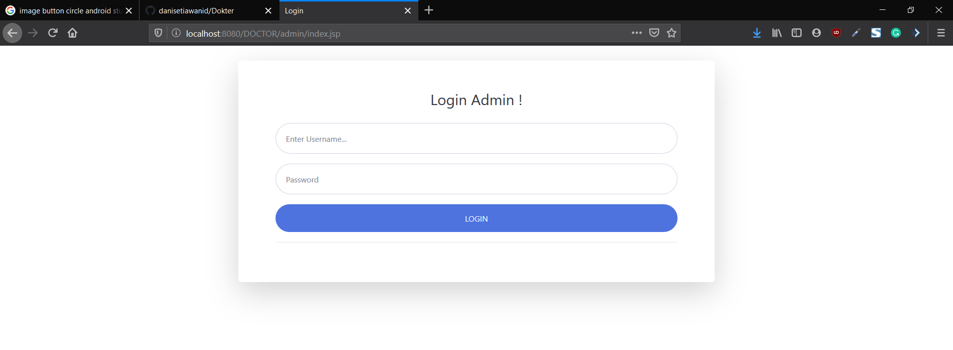

**Admin Dashboard**

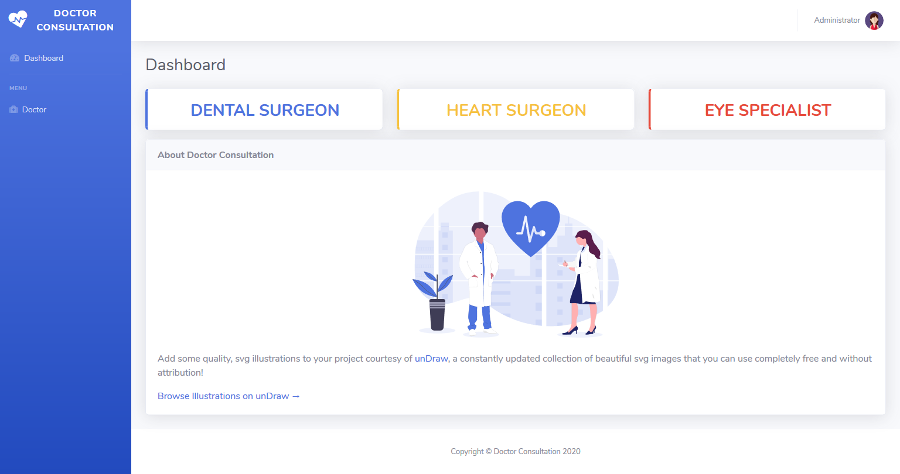

**Doctor Data**

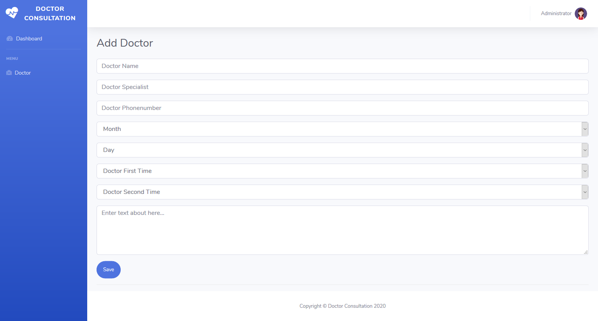

**Preview of Web**

*Doctor Consultation*

|  |  |  |  |  |  |
| --- | --- | --- | --- | --- | --- |
| NO | Activity Description | Planned Date  of Completion | Actual Date | Responsibility | Remarks |
| 1 | Create CRUDS (Create Read, Update, Delete, Search) | June 21th 2018 | June 22th 2018 | Aji |  |
| 2 | Create Content and Image Web | June 21th 2018 | June 22th 2018 | Fadhilah |  |
| 3 | Create Form | June 25th 2018 | June 26th 2018 | Fadhilah |  |
| 4 | Create Validation | June 27th 2018 | June 28th 2018 | Mindy |  |
| 5 | Create Servlet | June 28th 2018 | June 30th 2018 | Mindy |  |
| 6 | Create Java Server Pages | June 30th 2018 | July 1st 2018 | Mindy |  |
| 7 | Make a Paper | June 22th 2018 | June 23th 2018 | Fadhilah |  |
| 8 | Power Point | June 23th 2018 | June 24th 2018 | Fadhilah |  |
| 9 | Create Autentikasi | June 24th 2018 | June 25th 2018 | Aji |  |
| 10 | Create Autorisasi | June 29th 2018 | June 30th 2018 | Aji |  |
| 11 | User Interface | June 28th 2018 | June 29th 2018 | Aji |  |

**INDIVIDUAL PROJECT SCHEDULE**

**Doctor Data Table**

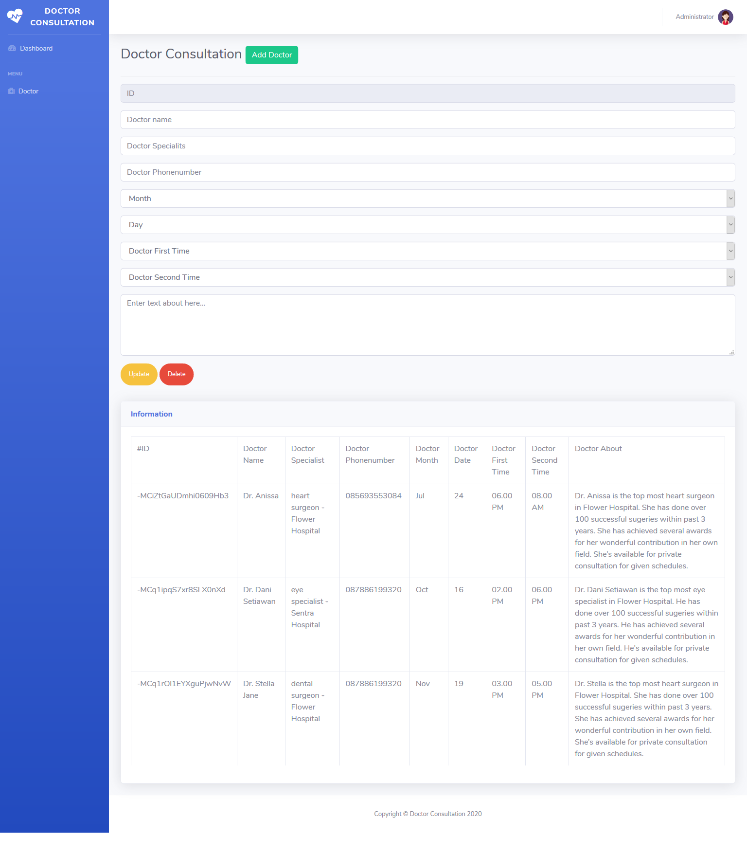

**Preview of app**

*Doctor Consultation*

|  |  |  |  |  |  |
| --- | --- | --- | --- | --- | --- |
| NO | Activity Description | Planned Date  of Completion | Actual Date | Responsibility | Remarks |
| 1 | Create CRUDS (Create Read, Update, Delete, Search) | June 21th 2018 | June 22th 2018 | Aji |  |
| 2 | Create Content and Image Web | June 21th 2018 | June 22th 2018 | Fadhilah |  |
| 3 | Create Form | June 25th 2018 | June 26th 2018 | Fadhilah |  |
| 4 | Create Validation | June 27th 2018 | June 28th 2018 | Mindy |  |
| 5 | Create Servlet | June 28th 2018 | June 30th 2018 | Mindy |  |
| 6 | Create Java Server Pages | June 30th 2018 | July 1st 2018 | Mindy |  |
| 7 | Make a Paper | June 22th 2018 | June 23th 2018 | Fadhilah |  |
| 8 | Power Point | June 23th 2018 | June 24th 2018 | Fadhilah |  |
| 9 | Create Autentikasi | June 24th 2018 | June 25th 2018 | Aji |  |
| 10 | Create Autorisasi | June 29th 2018 | June 30th 2018 | Aji |  |
| 11 | User Interface | June 28th 2018 | June 29th 2018 | Aji |  |

**INDIVIDUAL PROJECT SCHEDULE**

**User Login Login with Google Authentication**

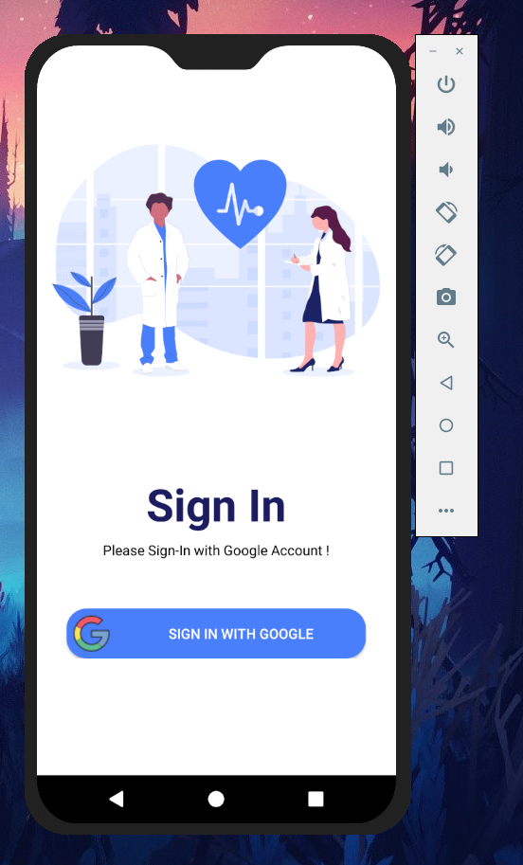 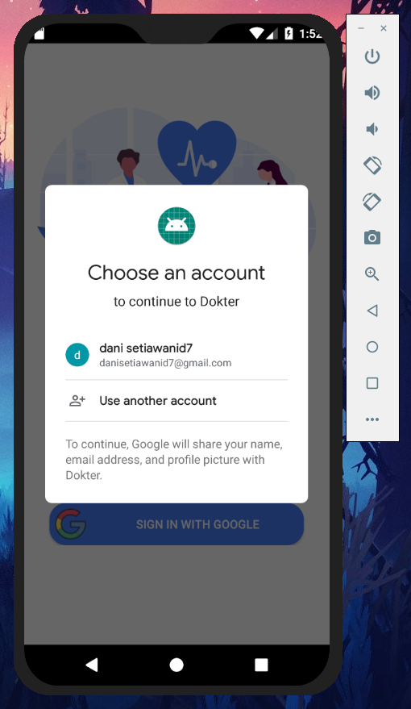

**Home Page Finding specialist**

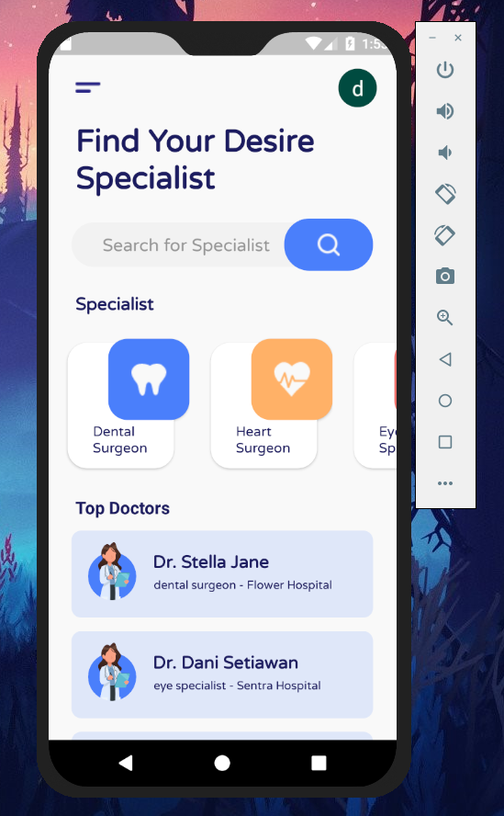 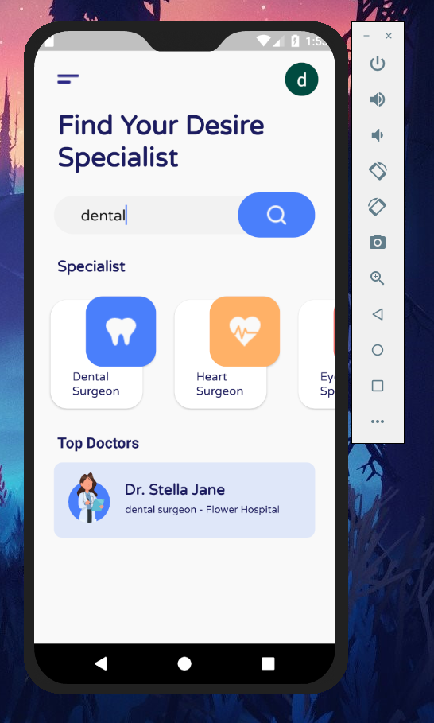

**Preview of app**

*Doctor Consultation*

|  |  |  |  |  |  |
| --- | --- | --- | --- | --- | --- |
| NO | Activity Description | Planned Date  of Completion | Actual Date | Responsibility | Remarks |
| 1 | Create CRUDS (Create Read, Update, Delete, Search) | June 21th 2018 | June 22th 2018 | Aji |  |
| 2 | Create Content and Image Web | June 21th 2018 | June 22th 2018 | Fadhilah |  |
| 3 | Create Form | June 25th 2018 | June 26th 2018 | Fadhilah |  |
| 4 | Create Validation | June 27th 2018 | June 28th 2018 | Mindy |  |
| 5 | Create Servlet | June 28th 2018 | June 30th 2018 | Mindy |  |
| 6 | Create Java Server Pages | June 30th 2018 | July 1st 2018 | Mindy |  |
| 7 | Make a Paper | June 22th 2018 | June 23th 2018 | Fadhilah |  |
| 8 | Power Point | June 23th 2018 | June 24th 2018 | Fadhilah |  |
| 9 | Create Autentikasi | June 24th 2018 | June 25th 2018 | Aji |  |
| 10 | Create Autorisasi | June 29th 2018 | June 30th 2018 | Aji |  |
| 11 | User Interface | June 28th 2018 | June 29th 2018 | Aji |  |

**INDIVIDUAL PROJECT SCHEDULE**

**Doctor Data**

